Aim
To perform edge detection on an image using the Canny Edge Detection algorithm in Python and OpenCV.

Apparatus / Software Required
- Google Colab
- Python
- OpenCV (cv2)
- Matplotlib
- Input image (.jpg, .png, etc.)

Procedure
- Open Google Colab and create a new notebook.
- Import OpenCV, Matplotlib, and the Google Colab file-upload library.
- Upload the required image.
- Read the uploaded image using cv2.imread().
- Convert the color image into a grayscale image using cv2.cvtColor().
- Apply the Canny Edge Detection algorithm using cv2.Canny().
- Set the lower and upper threshold values to 100 and 200.
- Display the original image.
- Display the detected edges.
- Compare the original image with the edge-detected image.

Code:
from google.colab import files
import cv2
import matplotlib.pyplot as plt

# Upload image
uploaded = files.upload()

# Get filename
filename = list(uploaded.keys())[0]

# Read image
image = cv2.imread(filename)

if image is None:
print("Error: Unable to read the image.")
else:
print("Image uploaded successfully:", filename)

# Convert to grayscale
gray = cv2.cvtColor(image, cv2.COLOR_BGR2GRAY)

# Canny edge detection
edges = cv2.Canny(gray, 100, 200)

# Display original and edge images
plt.figure(figsize=(10, 4))

# Original image
plt.subplot(1, 2, 1)
plt.imshow(cv2.cvtColor(image, cv2.COLOR_BGR2RGB))
plt.title("Original Image")
plt.axis("off")

# Canny edge image
plt.subplot(1, 2, 2)
plt.imshow(edges, cmap="gray")
plt.title("Canny Edge Detection")
plt.axis("off")

plt.tight_layout()
plt.show()
Output:
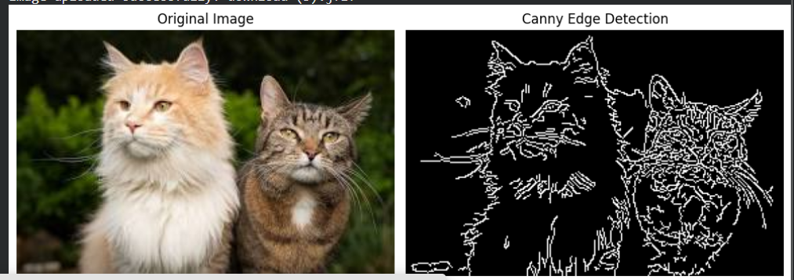

Result
The input image was successfully processed using the Canny Edge Detection algorithm. The important boundaries and edges present in the image were detected and displayed as a grayscale edge image.

